WEEK 3 PSTJ
Task 1: Java Date and Time
import java.io.*;
import java.math.*;
import java.security.*;
import java.text.*;
import java.util.*;
import java.util.concurrent.*;
import java.util.regex.*;

class Result {

public static String findDay(int month, int day, int year) {

Calendar c = Calendar.getInstance();

c.set(year, month - 1, day);

return c.getDisplayName(
Calendar.DAY_OF_WEEK,
Calendar.LONG,
Locale.ENGLISH
).toUpperCase();
}
}

public class Solution {
public static void main(String[] args) throws IOException {

BufferedReader bufferedReader =
new BufferedReader(new InputStreamReader(System.in));

BufferedWriter bufferedWriter =
new BufferedWriter(new FileWriter(System.getenv("OUTPUT_PATH")));

String[] firstMultipleInput =
bufferedReader.readLine()
.replaceAll("\\s+$", "")
.split(" ");

int month = Integer.parseInt(firstMultipleInput[0]);
int day = Integer.parseInt(firstMultipleInput[1]);
int year = Integer.parseInt(firstMultipleInput[2]);

String res = Result.findDay(month, day, year);

bufferedWriter.write(res);
bufferedWriter.newLine();

bufferedReader.close();
bufferedWriter.close();
}
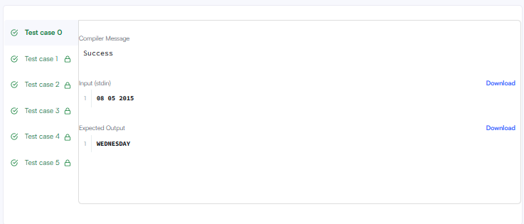
}
Output:
Task2: Number of Days Between Two Dates
class Solution {
public int daysBetweenDates(String date1, String date2) {

int y1 = Integer.parseInt(date1.substring(0, 4));
int m1 = Integer.parseInt(date1.substring(5, 7));
int d1 = Integer.parseInt(date1.substring(8, 10));

int y2 = Integer.parseInt(date2.substring(0, 4));
int m2 = Integer.parseInt(date2.substring(5, 7));
int d2 = Integer.parseInt(date2.substring(8, 10));

int days1 = getDays(y1, m1, d1);
int days2 = getDays(y2, m2, d2);

return Math.abs(days1 - days2);
}

public int getDays(int year, int month, int day) {

int total = 0;

// Days in previous years
for (int i = 1971; i < year; i++) {
if (isLeap(i)) {
total = total + 366;
} else {
total = total + 365;
}
}

// Days in previous months
int[] days = {
31, 28, 31, 30, 31, 30,
31, 31, 30, 31, 30, 31
};

for (int i = 1; i < month; i++) {
total = total + days[i - 1];

if (i == 2 && isLeap(year)) {
total++;
}
}

total = total + day;

return total;
}

public boolean isLeap(int year) {
if (year % 400 == 0) {
return true;
}

if (year % 100 == 0) {
return false;
}

if (year % 4 == 0) {
return true;
}

return false;
}
}
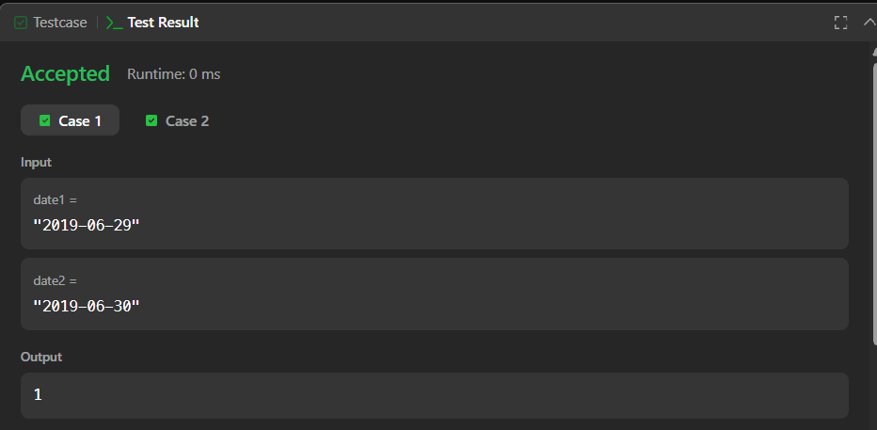
Task3: Day of the Year
class Solution {
public int dayOfYear(String date) {

int year = Integer.parseInt(date.substring(0, 4));
int month = Integer.parseInt(date.substring(5, 7));
int day = Integer.parseInt(date.substring(8, 10));

int[] days = {
31, 28, 31, 30, 31, 30,
31, 31, 30, 31, 30, 31
};

int total = 0;

for (int i = 0; i < month - 1; i++) {
total = total + days[i];
}

if (month > 2 && isLeapYear(year)) {
total++;
}

total = total + day;

return total;
}

public boolean isLeapYear(int year) {
if (year % 400 == 0) {
return true;
}

if (year % 100 == 0) {
return false;
}

if (year % 4 == 0) {
return true;
}

return false;
}
}
Output:
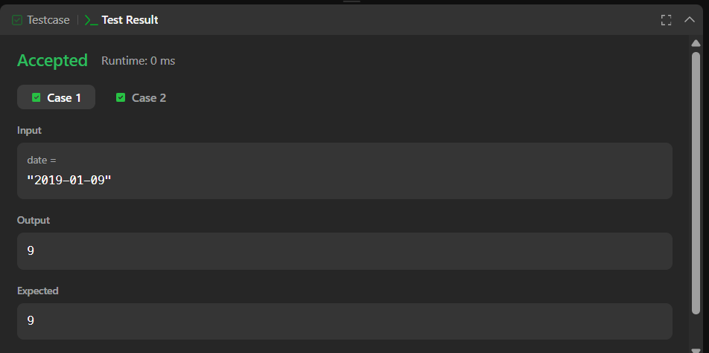
Task 4:
class Solution {
public String dayOfTheWeek(int day, int month, int year) {

String[] week = {
"Sunday",
"Monday",
"Tuesday",
"Wednesday",
"Thursday",
"Friday",
"Saturday"
};

int[] days = {
31, 28, 31, 30, 31, 30,
31, 31, 30, 31, 30, 31
};

int total = 0;

// Add days of previous years
for (int i = 1971; i < year; i++) {
if (i % 400 == 0 || (i % 4 == 0 && i % 100 != 0)) {
total = total + 366;
} else {
total = total + 365;
}
}

// Add days of previous months
for (int i = 0; i < month - 1; i++) {
total = total + days[i];
}

// Add extra day for February in leap year
if (month > 2) {
if (year % 400 == 0 || (year % 4 == 0 && year % 100 != 0)) {
total++;
}
}

// Add current day
total = total + day - 1;

// January 1, 1971 was Friday
int index = (5 + total) % 7;

return week[index];
}
}
Output:

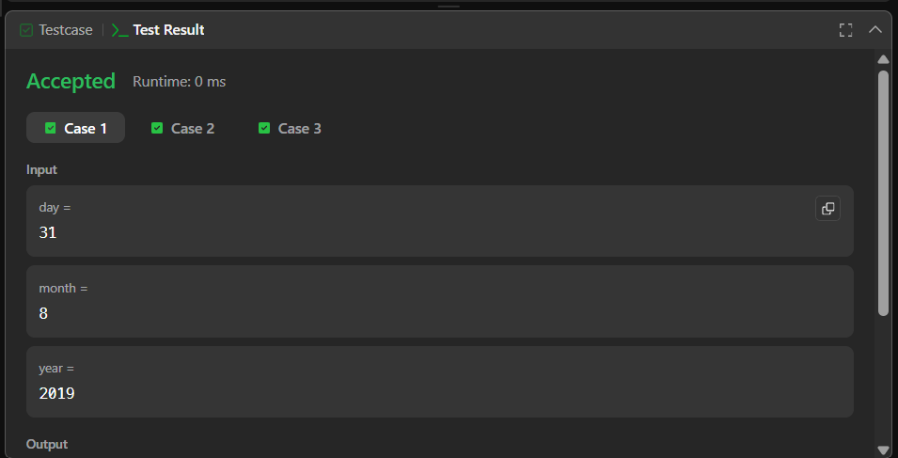
Task5:
import java.util.ArrayList;
import java.util.List;
import java.util.Scanner;
import java.util.PriorityQueue;
import java.util.Comparator;

class Student {
private int id;
private String name;
private double cgpa;

Student(int id, String name, double cgpa) {
this.id = id;
this.name = name;
this.cgpa = cgpa;
}

int getID() {
return id;
}

String getName() {
return name;
}

double getCGPA() {
return cgpa;
}
}

class Priorities {

public List<Student> getStudents(List<String> events) {

PriorityQueue<Student> queue = new PriorityQueue<Student>(
10,
new Comparator<Student>() {

public int compare(Student s1, Student s2) {

// Higher CGPA first
if (s1.getCGPA() < s2.getCGPA()) {
return 1;
}

if (s1.getCGPA() > s2.getCGPA()) {
return -1;
}

// Same CGPA -> name ascending
int nameCompare = s1.getName().compareTo(s2.getName());

if (nameCompare != 0) {
return nameCompare;
}

// Same CGPA and name -> ID ascending
return s1.getID() - s2.getID();
}
}
);

for (String event : events) {

String[] parts = event.split(" ");

if (parts[0].equals("ENTER")) {

String name = parts[1];
double cgpa = Double.parseDouble(parts[2]);
int id = Integer.parseInt(parts[3]);

Student student = new Student(id, name, cgpa);

queue.add(student);

} else if (parts[0].equals("SERVED")) {

queue.poll();
}
}

List<Student> result = new ArrayList<>();

while (!queue.isEmpty()) {
result.add(queue.poll());
}

return result;
}
}

public class Solution {
private final static Scanner scan = new Scanner(System.in);
private final static Priorities priorities = new Priorities();

public static void main(String[] args) {
int totalEvents = Integer.parseInt(scan.nextLine());
List<String> events = new ArrayList<>();

while (totalEvents-- != 0) {
String event = scan.nextLine();
events.add(event);
}

List<Student> students = priorities.getStudents(events);

if (students.isEmpty()) {
System.out.println("EMPTY");
} else {
for (Student st: students) {
System.out.println(st.getName());
}
}
}
}
Output:

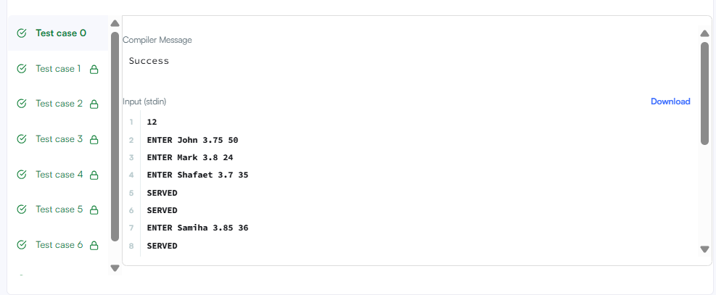
task 6:
import java.io.*;
import java.util.*;

public class Solution {

public static void main(String[] args) {

Scanner sc = new Scanner(System.in);

int n = sc.nextInt();

ArrayList<ArrayList<Integer>> list =
new ArrayList<ArrayList<Integer>>();

// Read the lines
for (int i = 0; i < n; i++) {

int d = sc.nextInt();

ArrayList<Integer> numbers =
new ArrayList<Integer>();

for (int j = 0; j < d; j++) {
numbers.add(sc.nextInt());
}

list.add(numbers);
}

// Number of queries
int q = sc.nextInt();

// Process queries
for (int i = 0; i < q; i++) {

int x = sc.nextInt();
int y = sc.nextInt();

if (y <= list.get(x - 1).size()) {
System.out.println(list.get(x - 1).get(y - 1));
} else {
System.out.println("ERROR!");
}
}
}
}
Output:

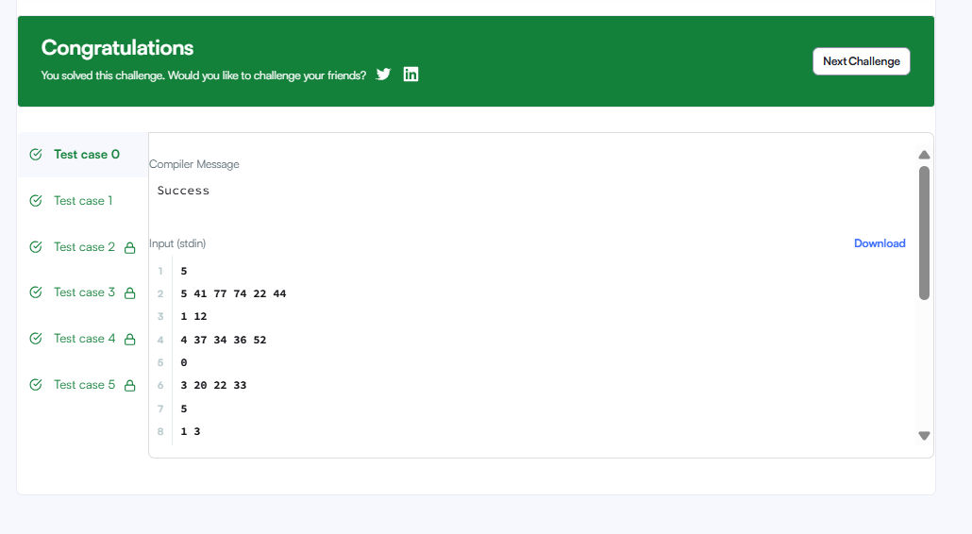
task 7:
import java.util.*;

class Solution {
public String largestNumber(int[] nums) {

String[] arr = new String[nums.length];

// Convert int to String
for (int i = 0; i < nums.length; i++) {
arr[i] = String.valueOf(nums[i]);
}

// Sort according to which combination is bigger
Arrays.sort(arr, new Comparator<String>() {

public int compare(String a, String b) {

String ab = a + b;
String ba = b + a;

return ba.compareTo(ab);
}
});

// If the largest number is 0
if (arr[0].equals("0")) {
return "0";
}

// Join all strings
String result = "";

for (int i = 0; i < arr.length; i++) {
result = result + arr[i];
}

return result;
}
}
Output:
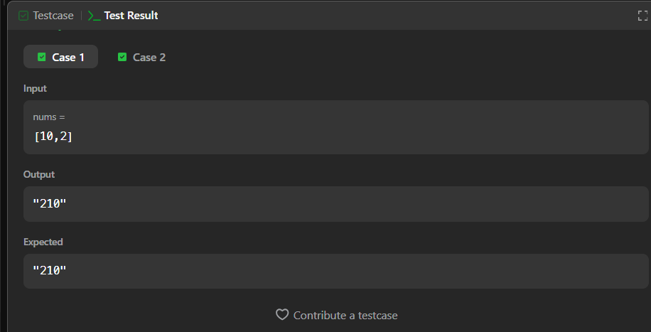
task 8:
class Checker implements Comparator<Player> {

public int compare(Player a, Player b) {

// Higher score first
if (a.score < b.score) {
return 1;
}

if (a.score > b.score) {
return -1;
}

// Same score -> alphabetical order
return a.name.compareTo(b.name);
}
}
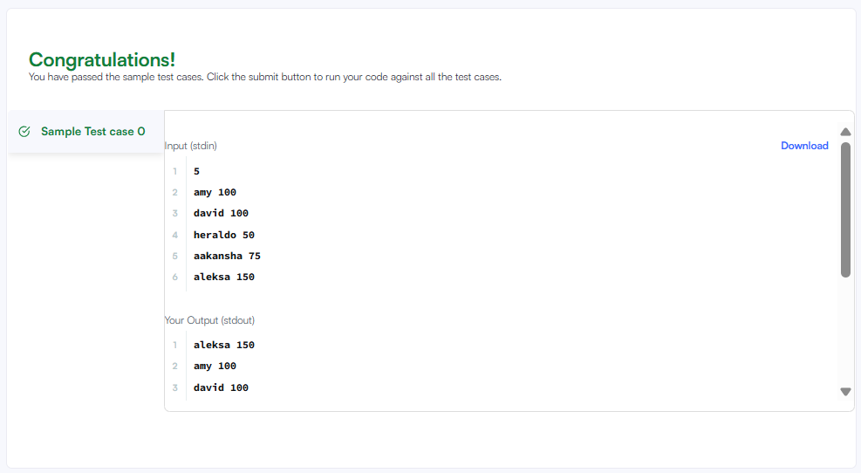
Task 9:
class Solution {
public String[] sortPeople(String[] names, int[] heights) {

for (int i = 0; i < heights.length; i++) {

for (int j = i + 1; j < heights.length; j++) {

if (heights[i] < heights[j]) {

// Swap heights
int temp = heights[i];
heights[i] = heights[j];
heights[j] = temp;

// Swap names also
String tempName = names[i];
names[i] = names[j];
names[j] = tempName;
}
}
}

return names;
}
}
